# **Marriage Compatibility - Astro Exceptions > Astro Rules**

*Dr. Balaji Ramanathan*

*******Dr. R. Balaji is a professional practising astrologer. He is working in a Central Govt. Organisation at Hyderabad. He has completed his Master’s Degree in Astrology in first class from Potti Sree Ramulu Telugu University. He has done research work in Progeny – KP System under their guidance of Dr. NVRA. Raja and Dr. Vijayalakshmi and awarded Ph.D. (Vedanga Jyothisha) from Yoga Samskrutam University, Florida, USA. He was awarded with Jyothisa Praveena in KP System under the guidance of Guruji. Late PVK. Punneswara Rao, founder of M/S. Universal college of Astrology, Hyderabad. Also undergone Nadi Astrology courses under the guidance Prof. A. V. Sundaram at ICAS, Hyderabad chapter and also from Prof.Satyanarayana Naik.*

My Guruji, Late Shri. PVK Punneswara Rao used to stress on an important point that all of us, students should be thorough in astrological rules, its exceptions and cancellations. He used to say that more than the rules; exceptions to the rules play an important role in determining the results of a particular chart. He opines most of the practising astrologers make inaccurate predictions by just applying basic/rudimentary rules without considering exceptions to the rules which alters the results. We have seen, in so many cases that afflictions/doshas in a chart get nullified/cancelled when we consider the exceptions to the rules. This can be very well seen in Kuja dosha, where the exceptions/cancellations are more in number than the number of rules in itself. In many of the horoscopes where Kuja dosha is seen with respect to Asc/Moon/Venus gets nullified while applying exceptions to the original tenets. Even Punarpoo dosha caused by Saturn & Moon connection gets cancelled by the connection of Sun with Saturn. But in practice most of the practising astrologers miss this point of cancellation and make inaccurate predictions.

This inaccuracy or wrong evaluation of a chart is commonly seen in marriage compatibility, where most of the astrologers restrict themselves in matching charts to the extent of looking into important Kutas/Poruthams namely (Rasi, Rasiadipathi, Vasiyam, Mahendra, Gana, Yoni, Dina, Stree Deergha, Rajju, Vedha, Nadi), Kuja Dosham, Dasa Sandhi, Papasamyam. But they seldom analyse in depth without considering exception rules in Kutas & in Kuja dosham, this apart, planet to planet synastry between the girl & boy chart is not being seen. Hence invariably, we might have come across two different versions being given by either of the sides (girl & boy) of the astrologers. Particularly in a marriage match-making, girl’s side and boy’s side astrologers do not give the same opinion. This is purely because of not making an effort to analyse in depth without considering the exceptions to the rules. Because of this, I would like to enumerate the exceptions in the Kuta matching.

The following are the nullifying factors, if present, can ignore certain incompatibilities in the Kuta matching: -

- The absence of Stree- Deergha may be ignored if Rasi Kuta and Graha Maitri are present.

- Though Graha Maitri is the most important, it need not be considered if the couple has their Janma Rasis disposed in one and seven from each other.

- Rajju kuta need not be considered in case Graha Maitri, Rasi, Dina and Mahendra Kutas are present.

- The evil due to Nadi kuta can be ignored

- If Rasi and Rajju Kuta present,

- If the same planet is lord of the Janma Rasis of both the boy and girl,

- If the lords of the Janma Rasis of the are friends

- In case of common Janma rasis, according to sage Narada, common Janma rasis would be conducive to the couple provided they are born in different constellations. Garga opines the asterism of the boy should precede that of the girl for a happy married life. In case of the reverse i.e., the constellation of the girl precedes that of the boy, that one should be rejected.

- In case the Janma Nakshatra of the girl and boy is same, the following nakshatras are approved- Rohini, Arudra, Magha, Hasta, Vishaka, Sravana, Uttarabhadra, and Revati.

- The effect is neutral in case of Aswini, Kritika, Mrigasira, Punarvasu, Pushya, Pubba, Uttara, Chitta, Anuradha, Poorvashada, and Uttarashada.

- In case of Swati, Jyesta, Moola, Dhanista, Satabisha and Poorvabhadra, it is not recommended. However, in case of Swati, opinions are divided.

- In case the Janma Nakshtra belongs to two signs (suppose Kritika), the pada of the girl should be the preceding sign. For example, if Kritika is the common Janma Nakshatra between the boy and girl, the girl should have her Janma Rashi in Mesha and the boy is Rishaba.

- The couple should not have the same Janma Rasi, same Janma Nakshatra and pada. However, with respect to Satabisha, Hasta, Swati, Aswini, Kritika, Poorvashada, Mrigasira, and Magha, the evil given rise to, by virtue of common Janma Rasi, Nakshatra, and Pada gets cancelled if the couple are born in the first pada.

- Kuja dosha is caused by placement of Mars in 2nd, 4th, 7th, 8th, and 12 reckoned from Ascendant, Moon and Venus in a both girl & boy horoscope. More importance is given to the presence of Kuja dosha in female horoscope. However, this dosha/affliction gets nullified/cancelled if Mars are placed in the signs mentioned below corresponding to different houses.

2nd house – Mithuna & Kanya

4th house – Mesha & Vrichika

7th house - Karakataka & Makara

8th house - Dhanus & Meena

12th house – Rishaba & Thula

- Placement of Mars in Simha & Kumbha causes no affliction/dosha whatsoever irrespective of analysing with respect to Ascendant/Moon/Venus.

- The dosha gets counteracted by the conjunction of Mars & Jupiter, Mars & Moon, and also presence of Jupiter & Venus in ascendant.

- When it comes to planet-to-planet matching/synastry between the girl & boy horoscopes by superimposing each other charts, priority is given to Saturn, Jupiter, and Nodes, but least importance is given to other planets. Gone are the days where the age difference between the boy & girl remained 5 to 7 years. In those cases, you invariably find perfect synastry of Jupiter, Saturn & nodes not occupying the same Rasis or 2/12 placements. In fact, the mere age difference of 5 to 7 years itself takes care of the mutual compatibility, wherein the placements of slow-moving planets occupy themselves in perfect synastry. But in recent times girls are not interested in marrying a boy who is older than them by 2 or 3 years. Hence, we come across in matching, where the placement of Saturn is occupying the same Rasis, Jupiter either in the same Rasis or in 2/12, in both these cases results in imperfect synastry, which is the reason for the cause separation and divorce. However, it is difficult for an astrologer to change this present trend, but in spite of this inadequacy, we can recommend mutual compatibility provided if Saturn is connected to Venus either by conjunction, aspects or Stellar level in each other’s charts or Jupiter’s connection to Mars/Moon in each other’s charts.

Hence, I conclude that while matching horoscopes for mutual compatibility utmost care should be taken and the charts should be analysed in depth in a holistic manner.

# **Rain fall Prediction Through Kartevahana Method of Vedic Astrology**

*ML. Arvinda Swamy*

Ancient scholars of India studied the 5 elements of nature Agni (Fire), Bhoomi (Earth), Vayu (Air), Jalamu (Water) and Akshamu (Sky) much before the now so-called modern science of Astrometeorology. Continuous observations of Celestial bodies and its effect on human’s life on earth were observed Through ages. they devised the rules based on the movement of luminaries like sun and moon and the planets Venus, Mars, Jupiter, Saturn and Chaya Grahas Rahu and Ketu which are the nodes of the Moon in Nakshatra Rashis or Zodiac signs.

For the benefit of mankind their observations and finding are given in the form of slokas in scriptures. All the events which are occurring on the earth are due to effect of celestial bodies. Based on the movement and positions in particular nakshatra rashis they devised the method of predicting the rains well in advance without the need of sophisticated instrument like satellites and Radars in those days.

Food is the main source of all the activities of living creatures in the world without food nothing can survive and sustain. Different types of foods and food products are generated by Agriculture and it is the main source of lively hood for more than 70 % population in India. Farming and agricultural practices done by farmers are solely dependent on rains and it will directly and indirectly effect the wellbeing of the society and economy of the country.

Farmers start farming from the onset of Rainy season / Monsoon in India. Rainfall dynamics will completely change the entire Agricultural practices like ploughing the soil, sowing the seeds, harvest and storing the crops will be dependent on timing of rain, nature of rain and quantity of rains.

Fertile lands, Quality seeds, man power, and good agricultural practices all are useless if we don’t have rains. If rainfall and quantity of rain is predicted in advance we can decide when to plough the soil, sowing seeds and nature of crops to be cultivated based on rainfall. Prediction of rainfall in advance has many advantages for farmers based on these they can decide which crops to be cultivated, Land area of cultivation, ideal time to start agricultural practices and precautions for harvesting and storing the crops. Rainfall prediction will not only improve the production and quality of crops but also minimize the agricultural expenses and debts of the farmers.

**India's climate is affected by Monsoon/Seasonal winds:**

South-west monsoon which blows from Arabian Sea and Bay of Bengal Sea to land after crossing the Indian Ocean bringing most of the rain in the country during June to September known as summer monsoon. Northeast monsoon (Post Monsoon) is from October to December in Southern Peninsula and is commonly known as Winter Monsoon which blows from land to Sea.

**Rain fall Prediction methods:**

Rainfall and prosperity of crops can be studied by predicting Monsoon/ Rainfall. Several prediction methods are given by great saints by Varahamihira, Parashara, Gargamuni and others in several texts for the welfare of the society. There are several methods in predicting the rains in a particular area depending upon the geographical conditions of the place. 1.Kartevahana method based on the sun and moon Transitions 2. Sapthadnadi, 3. Arudra Pravesham, 4. Nakshatra Prasna, and Jagadlagnam. Based on the type of method used rainfall can be predict/forecast rains ranging from 1 day to 2 days (Short range) weeks (Medium range) and whole rainy season (Long range). Rainfall and type of crops suitable are also predicted based upon the 60 Year Telugu calendar names, based on the position of Jupiter also rainfall predictions were done. Few methods based on observation of 1 to 3 days in Aashad month (Ashadi Yoga) When Moon transit into Swathi (Swathi Yoga), Rohini (Rohini yoga) and Mrugashira nakshatras can predict the rain fall for that whole year and the types of crops can be grown or crops which can survive during that period are also used for prediction.

Farmers will start the agricultural work depending upon the monsoon. Paddy crops and few other crops need more water and cultivators will look for monsoon rainfall. Rainy season in India start with the onset of South-West monsoon, generally begin in late May or early June month and ends in the month of September. Rainfall season starts with the sun entry into Gemini sign (Airy Sign) in Mrugasira Nakshatra and further movement of Sun in watery sign cancer will improve the rainfall. In India Rainy season will be for a period of 4 months from June to October. South west monsoon provides more rains in different regions of India whereas North -East monsoons also give rains but the amount of rainfall will be very low when compared to the North -East monsoon rainfall.

**Kartevahana method for predicting rainfall:**

Kartevahana rainfall prediction method is widely used in many parts of the country and it is very popular among farmers especially in southern states of India. Karte will give the status of the amount of rainfall for 14 days. method will not precisely tell on which day rain will be there but it will indicate the total amount of rain fall for that place based on which farmers will decide the farming practices like plough the soil, planting crops, harvesting crops and storing.

Kartevahana method involves tracking sun movement/ entry time in different nakshatras (each sign is about 30 degrees and Sun moves 1 degree per day and completes 30 days for each sign and covers entire zodiac of 360 degrees in 12 months). In every sign there will be 9 Nakshatra padas and 4 padas make one nakshatra spanning about 13.20 degrees per nakshatra. In each sign there will be 3 Nakshatras either in combination of 2 complete nakshatras and 1 incomplete nakshatra spreading to another sign. Entry of sun in particular Nakshatra and Moon Nakshatras at that time will give particular karte vahana. Each kartevahana has some value based on that value rainfall can be forecasted well in advance.

There are 2 methods for predicting rainfall based on the karte/ sun entry into particular nakshatra

**Method:1**

Kartevahana is the means of finding the amount of rainfall prediction at particular location for a period of 2 weeks in advance. This method involves tracking of Sun entry time into particular nakshatra and counting 27 nakshatras from sun entry time in a particular nakshatra in the zodiac sign to the moon nakshatra and the value obtained will be divided by 9 will give the kartevahana and each kartevahana represent certain amount of rainfall.

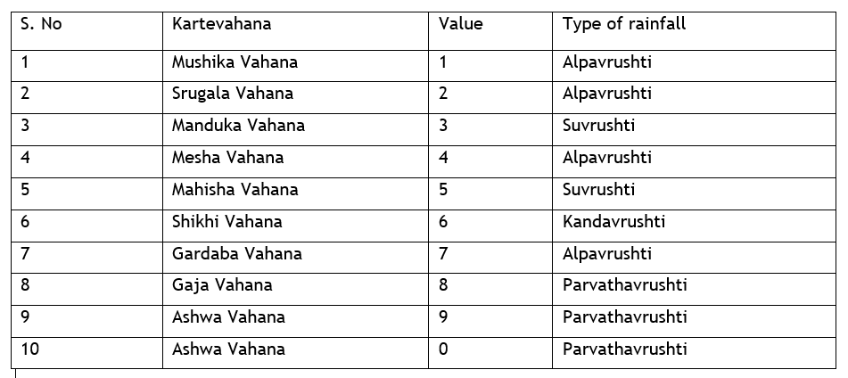

**Method:2 Karte prediction based on Nakshatra lingam (Gender)**

This method based on the Genders of Sun and Moon Nakshatras at the time of sun entry into particular karte will also predict the rainfall for particular location. The given below table shows the genders of the nakshatras.

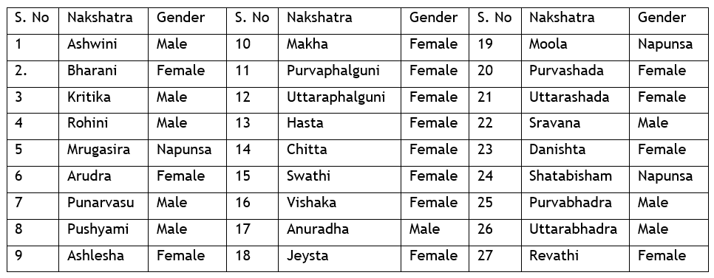

Based on knowing the genders of the sun and moon nakshatras on a particular day also we can predict the climatic conditions on that day and taken into consideration of the particular location climatology. Given below table provided climatic conditions and rainfall based on the season and geographic climatic conditions.

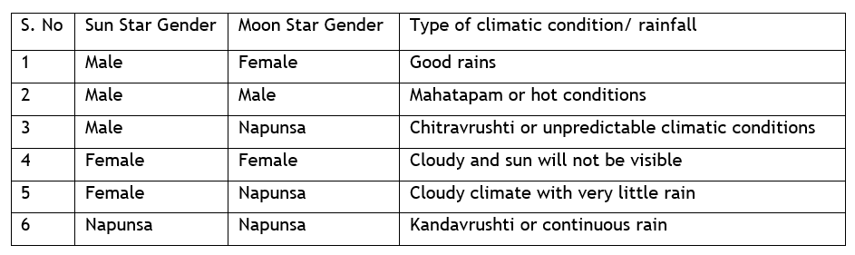

The day of Sun entry in these signs is to be noted from one sun rise to the next day sun rise. If the day happens to be Monday, Thursday and Friday, very good rainfall and crop production can be expected.

If the day happens to be on Wednesday, undue winds would occur and scatter the clouds. As a result, less rains would be experienced and prices rise due to scarcity of food grains.  If the day happens to be on Sunday, Tuesday and Saturday, medium rainfall would occur and scarcity of food grains would happen as a result. We have to check this for all the above 4 signs and arrive at the prediction connected with each of them.

Based on Kartevahana method rainfall prediction for the Telugu year plavanama samvatsara (2021- 2022) was done.

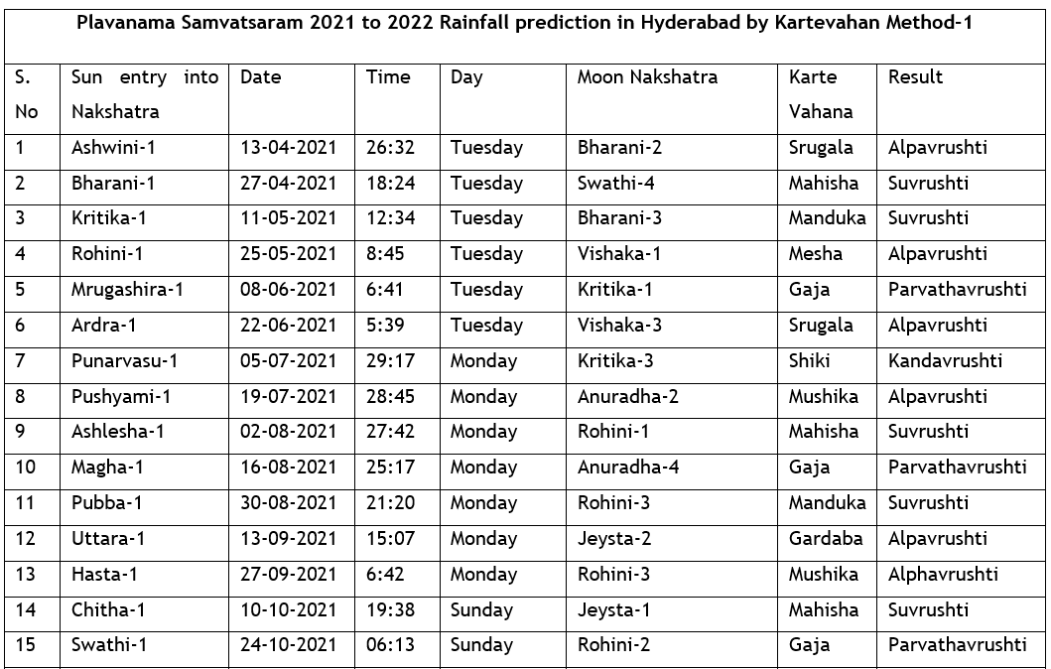

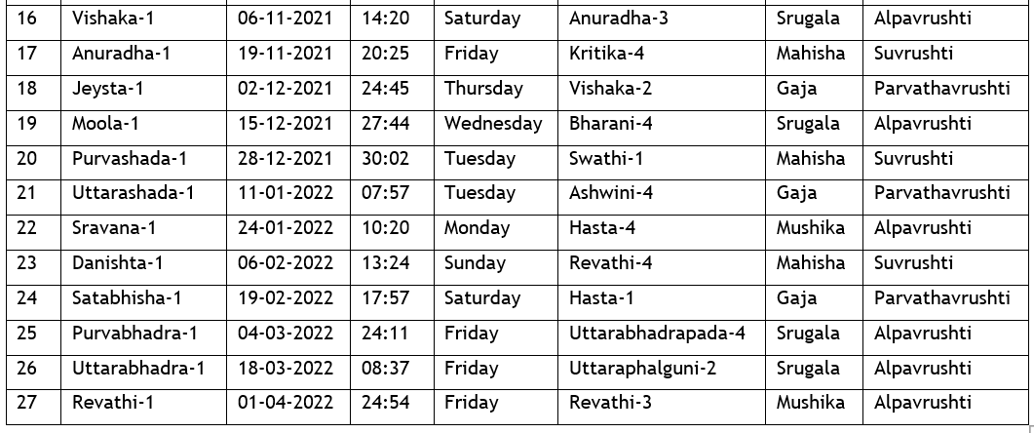

- Ashwinin Karte 13-04-2021 to 26-04-2021: Lagna at that time fall under the Capricorn which is earth sign and Moon in Purvabhadra Nakshatra indicates humidity and strong winds and hot climate due to the aspects of Mars on lagna very scanty or little rain in few parts of the Hyderabad.

- Bharani karte 27-04-2021 to 10-05-2021:

Libra Lagna is Airy sign and its house lord is Venus posited in Aries sign. Moon in Swathi Nakshatra. Lagna is aspected by both Jupiter and Saturn indicate good rains in the direction of South East direction and North East direction of Hyderabad and climate will be little cold in the evenings and with normal and pleasant climate in Hyderabad.

- Kritika Karte 11-05-2021 to 24-05-2021: Lagna is Leo (Fiery sign) and lagna lord sun is in 9th house along with moon in Fiery sign, Jupiter is aspecting lagna from airy sign indicates very hot winds in the day time and rains in North- East and East directions of Hyderabad.

- Rohini Karte 25-05-2021 to 07-06-2021: Lagna is Gemini which is airy sign and planet Mars is posited indicate very hot winds in North East directions of Hyderabad and in the evenings, climate will be little cold and with very scanty rains in few locations.

- Mrugashira Karte 08-06-2021 to 21-06-2021: Lagna is Gemini, Airy sign and Venus is posited in lagna aspected by Jupiter from Airy sign and presence of moon in Kritika star and Mars aspecting Jupiter from watery sign indicates good rains at North east direction of Hyderabad and in remaining places climate will be hot.

- Ardra Karte 22-06-2021 to 04-07-2021: Lagna is Gemini and lagna lord Mercury is earthy sign Jupiter is aspecting lagna and Mars is aspecting Jupiter and Saturn is aspecting Mars posited in watery sign indicates windy climate and little rains with thunders can be expected in North east direction of Hyderabad.

- Punarvasu Karte 05-07-2021 to 18-07-2021: Lagna is Gemini and presence of watery planet Venus in watery sign along with Mars. Jupiter aspects Lagna indicates good rains in the direction of East and south east direction of Hyderabad.

- Pushyami karte 19-07-2021 to 01-08-2021: Lagna is Gemini airy Sign and presence of Airy planet Mercury Lagna indicates less rains and the climate will be windy and pleasant with cool winds in the evenings.

- Aslesha Karte 02-08-2021 to 15-08-2021: Lagna is Gemini airy Sign and presence of planet Mercury and Sun in watery sign indicate depression/ cyclone like conditions in eastern side of Hyderabad, Bay of Bengal which is aspected by Saturn indicates good rains with thunders in North east directions of Hyderabad.

- Magha Karte 16-08-2021 to 29-08-2021: Lagna is Taurus and good rains are expected in South and south East directions of Hyderabad.

- Purvaphalguni Karte 30-08-22 to 12-09-2021: Lagna is Fiery sign and rains are expected in south west direction of Hyderabad.

- Uttara phalguni Karte 13-09-2021 to 26-09-20212: Lagna is Capricorn and no positive planets for rains indicates very low rains or no rains during this period.

- Hasta Karte 27-09-2021 to 09-10-2021: Lagna is Capricorn Jupiter and Saturn both are in lagna there will be no rains or little rains and the climate will be cool in south -west and western regions of Hyderabad.

- Chitta Karte 10-10-2021 to 23-10-2021: Lagna is Pisces watery sign and presence of 3 planets Jupiter, Moon and Saturn indicate cool climate in western and North west regions of Hyderabad and rains are expected in these regions.

- Swathi Karte 24-10-2021 to 05-11-2021: Lagna is Scorpio and presence of Mercury, Ketu, Sun indicates depression in the sea in Indian ocean towards Arabian sea due to these very good rains are expected in South and South east direction of Hyderabad and north and north east directions of the Hyderabad.

- Vishaka Karte 06-11-2021 to 18-11-2021: Lagna is watery Sign Aquarius and no positive effects for rain but the climate will be cooler due to presence of cold and watery planes are very nearer to earthy signs.

- Anuradha Karte 19-11-2021 to 1-12-2021: Lagna is Airy Sign Gemini aspected by Venus indicates rains in few regions of North east direction.

- Jeysta Karte 02-12-2021 to 14-12-2021: Lagna is Leo and presence of Sun and Mercury in watery sign in Scorpio indicates low pressure area in the Arabian Sea indicates good rains in the direction of East and South East Directions of Hyderabad.

- Moola Karte 15-12-2021 to 27-12-2021: Lagna is Airy sign Libra and Moon is aspecting from Aries and presence of Sun and Mercury in the Sagittarius Sign indicates low pressure areas in Arabian sea. Jupiter aspects lagna and there will be no rains are scanty rains in the south direction of Hyderabad and cold winds will be there during this period.

- Purvashada Karte 28-12-2021 to 10-01-2022: Lagna is Sagittarius and presence of Mecury, Sun and Moon indicates low pressure in the sea in Arabian sea. There will be rains in the South west directions of Hyderabad.

- Uttarashada Karte11-01-2022 to 23-01-2022: Lagna is Capricorn earthy sign and presence of Saturn and Mercury indicate cold winds are more prevalent in the West and North west directions of Hyderabad and good rains can be expected during this period

- Sravana Karte 24-01-2022 to 05-01-2022: Lagna is Capricorn earthy sign and presence of Saturn and Mercury and Sun indicate very col d climate and cold winds are more prevalent in the West and North west directions of Hyderabad and there will be no rains and few regions scanty rains can be expected.

- Danishta Karte 06-02-2022 to 18-02-20212: Lagna is earthy sign Taurus and there will be less rains in few regions.

- Shatabisha Karte19-02-2022 to 03-03-2022: Lagna is Airy Sign Gemini aspected by Saturn and Mars from Fiery sign, Jupiter and Sun in Aquarius windy sign indicates hot climate and warmer winds during this period and rains are expected with thunders in North east direction and South directions of Hyderabad.

- Purvabhadra Karte 04-03-22 to 17-03-2022: Lagna is Watery sign Scorpio and planet ketu is posited in lagna and there are no positive aspects very low rains occur during these periods in few regions of Hyderabad.

- Uttarabhadra Karte 18-03-2022 to 31-03-2022: Lagna is Aries Fiery Sign and there are no positive combinations for rains during this period few regions very little rains are expected.

- Revathi Karte 01-04-2022 to 14-04-2022: Lagna is fiery sign Sagittarius and there are no positive combinations for rains during this period.

According to the Telugu year Plava nama Samvatsaram rainfall will be average and different types of millets crops will be cultivated in large area.

*Note: With Guru ji Blessings these observations and calculations are made according to the astrology texts and literature. Any deviation in the results is only due to my observations and analysis but not due to the Astrology literature. I am trying my best to understand the subject and try to create awareness for ancient Astro science in predicting the Rainfall. I hope you will encourage me to improve the deeper understanding of Astrology knowledge and Science beyond our limitations. I hope you will accept this article and forgive me for mistakes*.

**ML. Arvinda Swamy**

**Ph. D 2019-2021**

**9246296946**

//Om Shree Gurubhyo Namaha//

# **ACCIDENT & SURVIVAL**

*- R. Subha Lekha*

*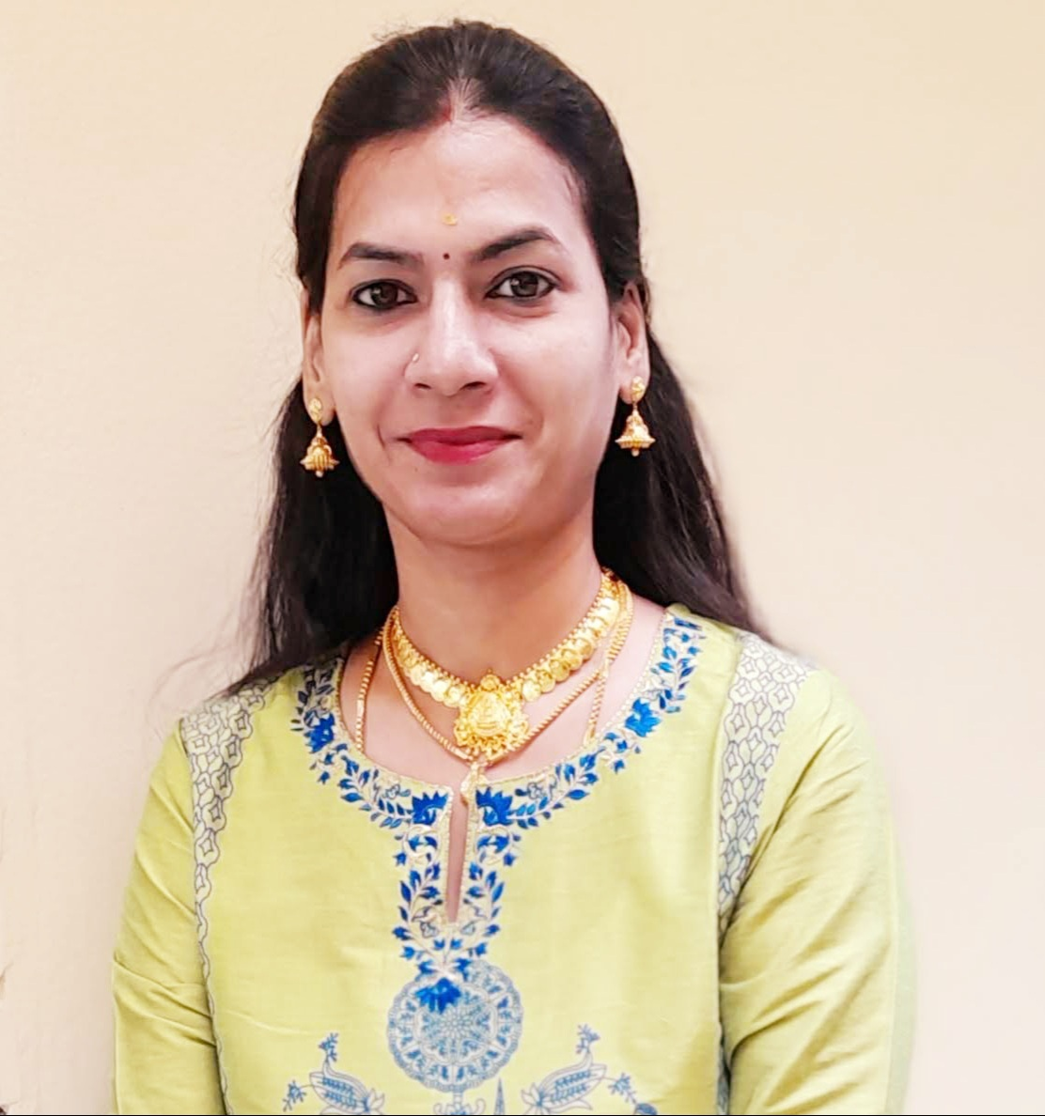R.Subha Lekha is a student of JKR Astro Research Foundation. She pursued her Masters in Vedanga Jyotisha holding First Rank from Yoga Samskrutham University, Florida USA. Presently she is pursuing her PhD in Medical Astrology under the guidance of Dr. N.V.R.A. Raja sir and also M.SC Psychology from Dr. B.R. Ambedkar University. She is by profession High School teacher.*

***Author’s Note:***

*I am glad that I have got an opportunity to write an article about Accident & Survival predictions through Jeeva & Sareera analysis.* *An accident or mishap is an unforeseen, unplanned, unexpected and undesirable event, especially one resulting in damage or harm. When a person meets with an accident and afterwards goes through the mental trauma, the 1st thing that comes to his/her mind on recovering is that he/she is having a bad time and/or the planetary positions are not favourable to him/her. Everything that happens in the life of an individual is influenced by Planets. In my opinion most of these accidents can be avoided and a good astrologer can advices better how to avoid these high risks moments of life.*

Every sign has its own quality. Hence every person born in a sign will have certain common and important traits. The Ascendant in Aries is the most prone for accidents whereas Virgo is least prone for accidents. This is because of the excess nervous energy the Aries lagna native and his inability to control it properly. Similarly, Pisces lagna native is also prone to accidents. The two-faced fish that Pisces represents cannot take decisions quickly due to their weak reflex action. The Virgo lagna native is more cautious and will always think twice before initiating action. Libra natives are well balanced and hence they are not generally prone to accidents. In a general manner the natives with Ascendants in the Fixed signs (Taurus, Leo, Aquarius) are less prone to accidents. They do not like changes, experimentation and hence they follow a fixed routine which probably is the reason.

The sign occupied by the Sun plays an important part in determining the vitality of the native. The more the vitality the better the strength to recuperate and less the damage incurred. Sun is very hot and a fiery planet. It is comfortable when it occupies similar signs. But when it occupies Watery signs like Pisces, Cancer and Scorpio it will not be comfortable and hence cause accidents. Similarly, when Sun occupies Sagittarius, Capricorn the fiery nature gets centred and concentrated to a particular location and this protects the individual. Similarly, when the Sun occupies the fixed signs Taurus, Leo and Aquarius the fiery nature seems to be controlled by the individual and hence there is less chance of harm and accidents.Planets Mars and Saturn Rahu ketu are associated with Accidents. Mars is the symbol of getting hurt. Mars is the lord of blood and violence, firearms, weapons. Rahu gives sudden events in life. So, it represents suddenness/sudden accidents in life. Venus role is also important when it comes to accidents by vehicle. Venus is the karaka of vehicles. Saturn is responsible for the accidents occurred by iron or machines. Mars is responsible for the accidents occurred due to fire or explosion/explosive material. Saturn also responsible for the accidents occurred due to animals. Moon is responsible for the accidents happened by water. Ketu in the 8thth house causes accidents. The planet Mercury rules transport in our immediate environment including bikes, scooters, cars, etc. For any immediate transport accident, we look to Mercury, Gemini, or the 3rd house. For long distance travel we look to Sagittarius, Jupiter or the 9th house*.*

Moon plays an important role in accidents of childhood as Moon refers to childhood. Natives who are prone to accidents can have some specific placement of planets or planetary combinations in their birth chart. Position of Rahu and Mars in ascendant or in 2nd house, Mars or Saturn in ascendant, mars or Saturn in 3rd house, mars or Saturn in 5th house, Mars and Saturn in 2/12, 6/8 combinations, Saturn, Moon, Mars in 2nd, 4th , 10th , 12th Houses, afflicted 4th house and 10th house.

Accidents may also occur during the Dasha and bhukti of maraka and badhaka lords or planets placed therein. For the timings of accident dasha period needs to be checked up to sookshma level. When these combinations are connected with the accident-prone houses (4,8,12) give accidents or hospitalization during its period. Connection with 6th house can also give accidents.

**MEGASTAR CHIRANJEEVI**

Chiranjeevi (Konidela Sivashankara Vara Prasad) was born on 22 Aug 1955, 10:20hrs, at Mogalthur, Narsapur, West Godavari Dist., A P. Chiranjeevi is a South Indian mega film star and a political leader from Andhra Pradesh.

He met with a major accident while he was travelling from Hyderabad to Chennai by air. It was around 7.59am on November 15, 1993, that due to technical problem, the flight had to be crash-landed in agricultural fields in Chittoor district of Andhra Pradesh. The pilot of the flight managed to crash-land the flight without any injuries or any casualties to the passengers.

We will study this megastar’s chart, applying Jeeva/sareera principles to arrive at timing of accident and observe effects of accident.

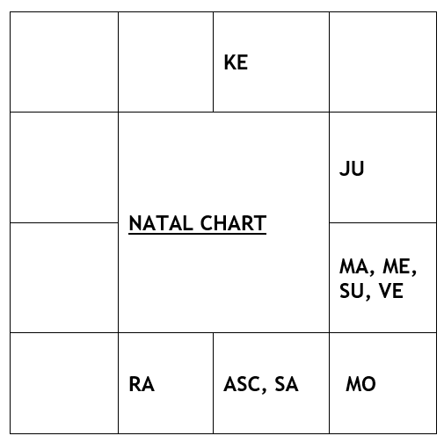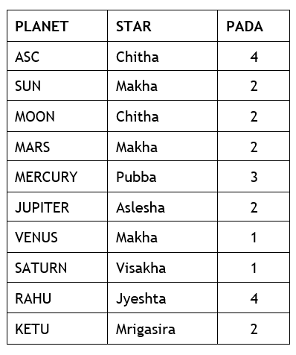

**OBJECTIVES: To validate**

“Whenever DBA gets connection with 4,6,8,12th houses and maraka Mars then events like accidents may happen”.

“If same DBA gets connection with 5th, 11th houses and strong yogakaraka then cure/ survival is assured”.

“The yog of accident could be numerous but if Jupiter aspect is on lagna or 5th lord in the natal chart then native will be saved during DBA and transit.”

**OBSERVATIONS**

- Yogakaraka Planet is Mercury

- Digbala Planets are Mercury, Jupiter and Rahu

- Bhinnapada Planets are Ketu, Moon and Saturn

- Maraka Planet is Mars

- Badaka Planet is Sun.

- Mars and Kethu in Sookshma Nakshatra Parivarthana.

In Natal chart we observe that native is born in Tula lagna. For Tula lagna, Mercury is the yogakaraka, Mars is the maraka and Sun will be the badaka. 4th and 5th lord Saturn is posited in lagna which is his exaltation house and in airy sign.

As per Meena2 principle, **“Planets in the house will not deliver the result, but its star lord will deliver the results favorable or unfavorable”.**

- Saturn, located in lagna kendra, is in the star of Jupiter who happens to be the 3rd and 6th lord posited in 10th house. Jupiter is in exaltation. So, Saturn will deliver the results of 1,3,4,5,6,10 houses. Also, Saturn aspects its star lord the 6th lord Jupiter through 10th aspect.

- 1st and 8th lord Venus is in 11H of Labhasthana also a badaka house. Venus is in the star of Ketu who is posited in 8H. Saturn aspects Venus also.

- 9th & 12th lord Mercury who is yogakaraka for the native is posited in 11H. Mercury starlord Venus who happens to be the 8th lord together is in conjunction with 11th lord Sun, badaka planet.

- Due to above reasons, accident had to happen during Saturn dasa, Saturn bukti and Mercury antara.

- Karaka for accident Mars who is the 2nd & 7th lord which is maraka houses for the native is posited in 11th H with conjunction badaka planet Sun, 8th lord Venus and 12th lord Mercury.

- Dasa and Bhukti lord Saturn through Bhinnapada gets connection with 2H of Maraka aspecting karaka Mars posited in 11H through 10th aspect. Mars also aspects dashadipathi Saturn. Saturn aspects 8H posited Kethu. 8th H indicates for sudden events.

- Antara lord Mercury is a yogakarakadipathi and 12th lord.

So, here we could observe that DBA has got strong connections with 6,8,12 houses and karaka Mars, events like accidents indicated.

**Transit Chart Analysis**

The native was running **Saturn Dasa – Saturn Bhukti – Mercury Antara.**

Saturn dasa started from **14-05-1993 to 13-05-2012**.

This event occurrence is validated in transit chart as described here below.

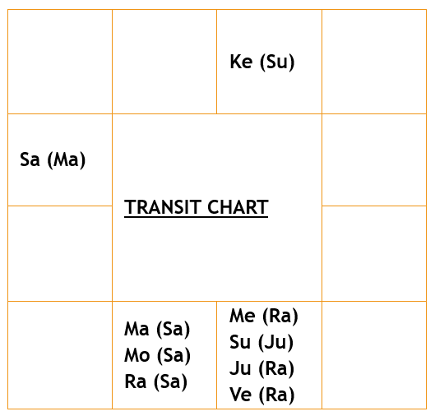

In transit, Dasha and Bhukti lord Saturn is in his own house of Kumbha an airy sign is aspecting natal posited badakadipathi Sun, karaka Mars, 8th lord Venus and 12th lord Mercury. Sun in 11H is strong in Leo along with Yogakaraka Mercury in transit came above the natal dasha and bhukti lord saturn helped the native to survive the accident with no injuries or casualties.

Sudden events like accident happened because of karaka mars in transit is in 2H from natal lagna which is his own house Scorpio. Posited above the natal bhinnapada saturn. Here to be noted that Mars and Saturn are in ‘**SOOKSHMA NAKSHATRA PARIVARTHANA’.**

**“Whenever DBA has got 5th, 11th  houses with Yogakaraka connections to DBA then Survival or recovery is assured”.**

**Jeeva and Sareera Planets of 1,6,8,12th bhavas and Mars are shown below.**

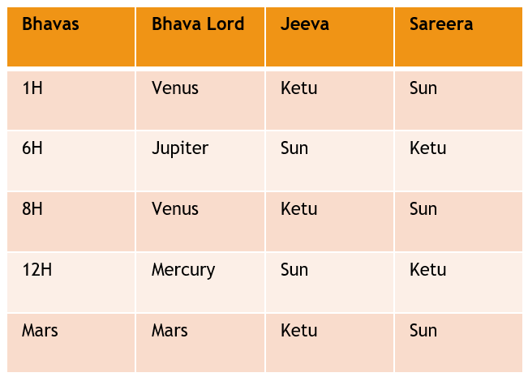

**For Cure**

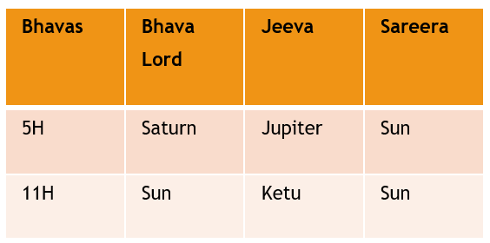

**JEEVA SAREERA ANALYSIS**

**“Whenever Jeeva and sareera planets of 4,6,8,12th houses and karaka mars get connection with DBA then accident like events happen”.**

- 1st & 8th Lord Venus is in the star of Ketu, so Ketu becomes Jeeva planet. Jeeva planet Ketu is in the star of Mars. Mars is conjoined with sun and Sun is strong in Leo snatches the power from Mars and becomes Sareera planet.

- 6th Lord Jupiter is in the star of Mercury and Mercury is in Leo sign conjoined with bhava lord Sun. Sun snatches power from Mercury and becomes Jeeva planet. Jeeva planet sun is in the star of Kethu, so Kethu becomes Sareera planet.

- 9th & 12th lord Mercury is in the star of Ketu and Ketu becomes Jeeva Planet. Jeeva planet ketu is in the star of Mars, and sun owns the house becomes Sareera planet.

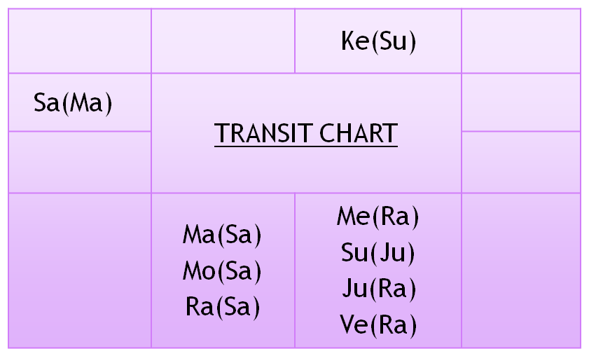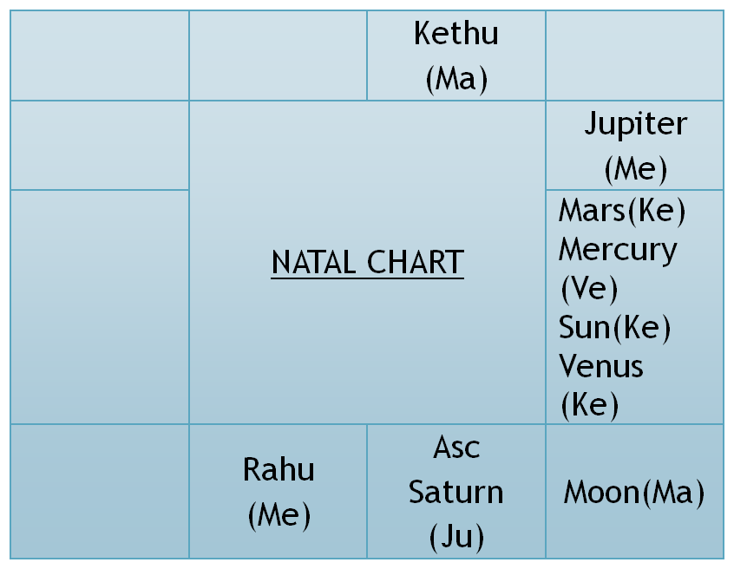

- Karaka Mars is in the star of Ketu . Ketu becomes Jeeva planet. Jeeva planet Kethu is in the star of Mars and is with sun. So, sun becomes Sareera planet.

- In transit , Sun the Jeeva planet of 6th & 12th house and sareera planet of 1st, 8th and karaka Mars is above natal dashadipathi and bhukti lord Saturn.

Jeeva planet of 1st,8th and karaka mars and sareera planet of 6th & 12th house Kethu is in the star of Sun who is the 11th lord the labhadipathi. Ketu is aspected by natal saturn through bhinnapada.

**Note :** Ketu in natal and transit chart is in Taurus sign which indicates agricultural land. The native’s flight was crash landed in agricultural field.

**Conclusion :**

“Whenever the Jeeva and Sareera planets along with DBA gets connected to 5th & 11th houses or Yogakarakadipathi then recovery or survival is assured”

**Om Gurubhyo Namaha**

**TIMING OF EVENT-In vitro fertilization**

***- Prof. Ramanujam Kathyayani Devi***

***(Senior faculty JKR-Astro research foundation)***

***Ph: 8886591136 vikramkathy@gmail.com***

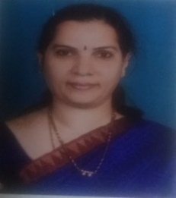 *Pranams to Siddha purusha Paramapujya Shri.N.V.Raghavachari garu and Pranams to my Guru Prof.N.V.R.A. Raja garu founder JKR Astro Research foundation. Dr.Raja’s Nakshatra Prasna plays a very important role in identifying the disease and the success rate of the surgery precociously.*

“An ounce of Prevention is worth a pound of cure” **Classical texts like Linda Goodman’s star signs (page no: 48)**

**Planning for a successful surgery:** Meena 2 method is accurate for a successful outcome of surgery, after spending lots of money, we get depressed if the success rate of a surgery is low. One such case happened with my cousin daughter ,who was married 10yrs back suffered with PCOD problems underwent a treatment for the same. Gynaecologist suggested IVF and the IVF failed twice after spending about 5-6 lakhs every time the success rate was zero with a depressed heart the native approached me and with the blessings of Guruji put the Prasna chart and correlated the event with the natal chart to find out what went wrong.

**Classical texts like Linda Goodman’s star signs (page no: 44) says**

- When Moon in Taurus ruling neck and throat one should not go for tonsillectomy.

- When transit Moon is passing through Scorpio ruler of reproductive organs a prostatectomy or hysterectomy should not be performed.

- When Moon is in Capricorn or Aries (Capricorn ruling teeth and bones) and Aries ruling head in general no dental surgery should be performed.

- Moon controls the ocean tides and timing of opening of oysters.

- New Moon and Full Moon in general crime rate increases.

- Moon controls the menstrual cycles in Women body emotions.

**Shad chakras in Medical Astrology:**

**- Mooladhara chakra:** (Root chakra) rules the earthy signs like Taurus/Virgo/Capricorn. It is concerned with family, health, Career 2/6/10 artha trikona(Imbalance or deficiency may lead to obstacles in life ,lack of confidence, insecurity fickle mindedness and phobia.

**- Sacral or swadhistana chakra:** Rules emotions like love. Likes and dislikes creativity relationship and sexuality. Water is the element rules the Cancer/Scorpio and Pisces balance these emotions 4/8/12 Moksha trikona governs issues related to Moon deficiency leads to emotional distress problems in relationship, lethargy, Jealousy, Infatuation and desire to be loved.

**- Solar plexus or Manipura chakra:** Fire energy resides in solar plexus which desires for power they are Aries/Leo/Sagittarius the 1/5/9 or Dharma trikona. Desire to control everything lack of confidence Impatience.

**- Heart or Anahata chakra** :Gemini /Libra/Aquarius-Love ,intimacy, forgiveness, gratitude, compassion, trust and empathy governed by 3/7/11 Kamatrikona.

**- Throat or Visuddha chakra**: Expression communication and Mercury rules this chakra. Planets placed in the 2nd house indicates throat.

**- Third eye or agna chakra** –Jupiter and Saturn govern planets of the 3rd eye knowledge and the power to execute them.

**- Crown or the Shahasrara** chakra: Sun is the form of divine energy which governs the crown chakra awareness, consciousness, and enlightenment spiritual energy are felt in this chakra.

When the shad chakras are in good control of the human body then one can be free of any diseases.

**Timing of Child birth:**

- Jupiter Putra karaka transiting in the 1/5/9 houses from the Natal lagna or Natal Jupiter or Natal Moon child birth is indicated.

- Jupiter transiting in the 5th star or 5th lord star wonderful prospects of child birth are foreseen.

- During child birth , if there is no 12th House connection child may not be delivered in the hospital.

- For hospitalized patient if there is no 11th connection patient will not be discharged from the hospital.

**IVF: In vitro fertilization : Favourable transits for IVF**:

- Putrakaraka Jupiter transiting in the favourable houses from Natal Lagna or the Moon sign or the Natal Jupiter gives beneficial results.

- Jupiter conjoined with Ketu in 2/5/11 houses it is favourable for medical support.

**IVF: In vitro fertilization : Unfavourable transits for IVF**:

- Putrakaraka Jupiter transiting in the 8th from the Natal lagna or Moon sign or Natal Jupiter avoid IVF.

- Putrakaraka Jupiter transiting in the 8th from the transit lagna or Moon sign or Jupiter avoid IVF.

- Dasa lord /Bukti lord or Anthera lord transiting in the 8th House IVF may fail.

- If Dasa lord transiting in vipath tara 3/5/21/12/14/5/23 stars from the birth star avoid any medical support for IVF.

- Jupiter and Rahu conjoined in the 5th house no positive results are seen.

- Dasa lord transit in the Mars star or aspected by the Mars Medical termination of Pregnancy or Failure of IVF is foreseen.

- Jeeva and Sareera planets of the 5th bhava should not be placed in 6/8 in natal or transit

**Example chart:**

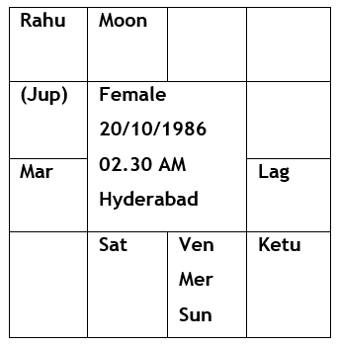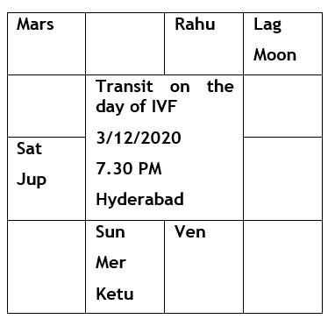

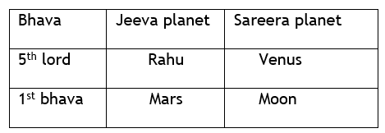

**Native was running Rahu Dasa/Ketu bukthi/Ketu anthera from 29/9/2020 to 24/2/2021**

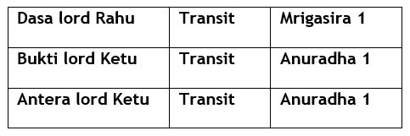

**Analysis from the natal chart:** 5th lord Jupiter in the 7th house obviously indicates a love marriage. Putrakaraka Jupiter Jeeva and Sareera planets are Rahu and Venus are in 6/8 positions in the Natal chart. Panchamadhipathi Jupiter in the Rahu star and star lord Rahu posited in the 8th house from the natal Lagna with Jeeva and Sareera posited in the 6/8 houses indicates the native suffered from PCOD problems for which she underwent treatment .Here Jupiter is hemmed between malefic Mars and Rahu.

With the approval of the gynaecologist, she went for IVF ON 3/12/2020 after spending 5-6 lakhs, she conceived but aborted in the 4th week of pregnancy. When worked out in Meena 2 method the day she went for IVF Jupiter was transiting in the 8th from the lagna and the Moon .Jupiter was transiting on the Natal Mars in the lagnadhipathi Sun star (which is again in the 12th from the natal Jupiter). Which was not a favourable transit for IVF.

Jeeva and Sareera planets of the 5th house Rahu and Venus were 6/8 both in the natal and the transit chart also indicating a failure of the IVF.

Dasa lord **Rahu** (Jeeva planet for the 5th house) Posited in the 8th house in the natal chart will give the results of House lord Jupiter and star lord Mercury. Both in the Natal and Transit Rahu is posited in the **12th** from the Moon. Rahu transits in the Mars star (Mrigasira) which was not a favourable transit for IVF.

Bukthi and Anthera lord **Ketu** transits in the house of **Mars 6th house** with the ( lagnadhipathi Sun) and Mercury. Mars is the Jeeva planet for the first house /Sareera planet for the 6/7 house and Jeeva planet for Ketu.

Ketu is transiting in the star of Saturn who is the **8th** lord in the transit chart.

Hence the Dasa bukthi and Anthera lords get connection of the dusthanas. Rahu gives the results of Jupiter (Rahu is the star lord of Putrakaraka Jupiter in the natal chart)

**References**:

: Prof. NVRA Raja Concepts of Jeeva and Sareera/Class notes dictated

: Linda good man’s star signs

: Satya Sree Raja Nakshatra Digbala and Gunas

**GURVE SHARANAM**

Om Sree Gurubhyo Namah

**STELLAR EFFECTS PLANETS IN SOOKSHMA NAKSHATRA PARIVARTHANA**

*~ Dr. R.Chandra Lekha*

*I, Dr. R.Chandra Lekha is a faculty in JKR Astro Research Foundation. I have pursued my Masters in Astrology from Potti Sreeramulu Telugu University and Masters in Vedanga Jyothisha and PhD from Yoga Samskrutham University, Florida USA under the guidance of Dr. NVRA. Raja sir. Presently I am pursuing my MSC Psychology from Dr. B.R.Ambedkar University. I am by Profession High School teacher and an Astro Consultant in AstroYogi.*

**Successful MBBS Doctor**

**Male, Date of Birth: 31.05.1994, Time of Birth: 24.05 hrs, Place of Birth: Manama, Bahrain.**

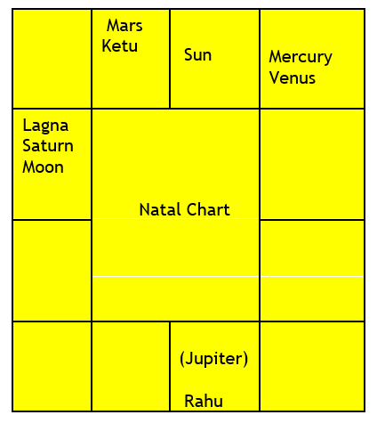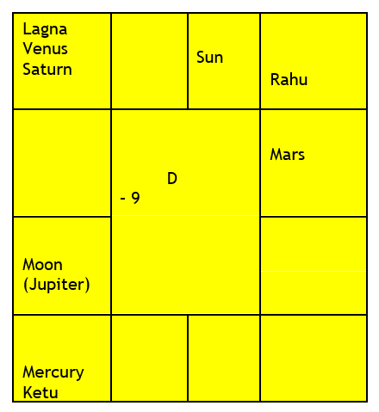

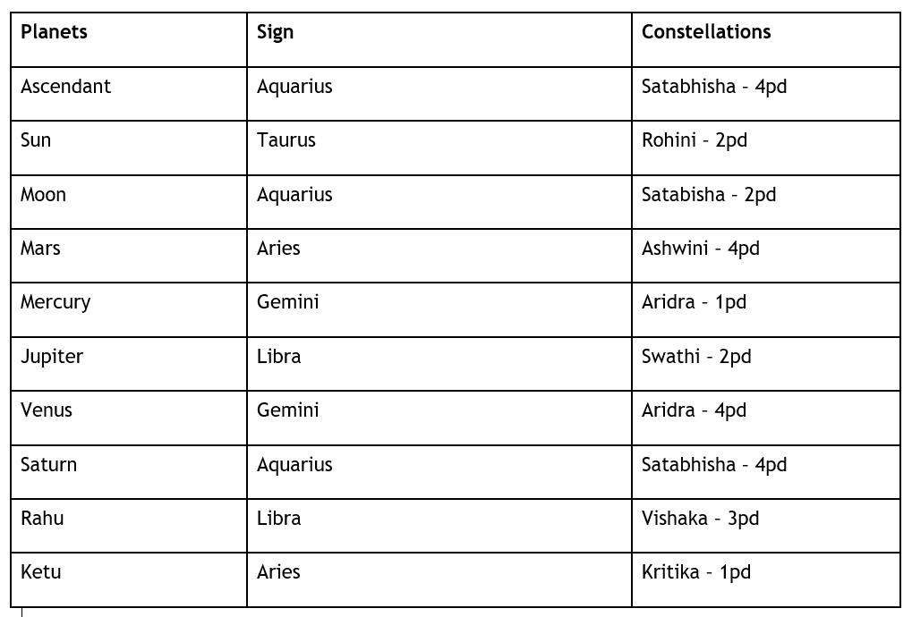

The native is a Rank holder during his Intermediate in Kerala and through Scholarship he has successfully completed his MBBS in Assam. He hails from an affluent family and is leading a comfortable life and looking forward for his MD.

**SOOKSHMA NAKSHATRA PARIVARTHANA**

According to Raghavacharyam Principles, the planets in Sookshma Nakshatra Parivarthana results should be carefully watched. According to Guruji, among the Parivarthana - Sthoola and Sookshma. Sthoola Parivarthana is said to be parivarthana between two houses or bhava. Sthoola gives external results. Sookshma Parivarthana is said to be exchanging of nakshatra between two planets. Sookshma gives results in deep. Among Sthoola and Sookshma Raghavacharyam says Sookshma will give more intense results. Whether it will give favourable or Unfavourable results that is to be seen according to Pancha Siddhanta.

Karaka for Medicine - Sun , Mars and Ketu.

Higher Education in the chart is seen through 5th house (use of Knowledge) and 9th house (higher education).

For Medical field

1. 6th house (Service, diseases)
2. 7th house (Patient)
3. 8th house (diagnosing the disease, Longevity)
4. 12th house ( Hospitals, bed)
5. Moon the karaka for mind
6. Mercury the natural 6th lord
7. 10th house of Profession (5th to 5th house)
8. 11th house of Gains and
9. Strong connection between 6th or 12th house either through Sookshma Parivarthan or Sthoola Parivarthan or conjunction or through aspect indicates profession related to medicine.
10. Strong connection between 8th or 6th or 12th house either through placement.

For Medicine studies after 10th Bipc is taken and after Intermediate appearing for NEET exam and then entering into MBBS. Whether the native can finish it properly or will the native get diverted after Intermediate that is all to be seen according to the

Dasa, Bhukti and Antara. If these DBA planets are strongly associated with connection of 6th house,8th house or 12th house either by way of PAS, and karaka Sun and Mars for medicine, the events related to will happen.

**ANALYSIS:**

**- Lagnapadhadhipathi** is Satabhisha lord Rahu is in Sookshma Nakshatra parivarthana. Rahu is conjunct with 11th lord labhadhipathi Jupiter. Lagna and Lagna lord is aspected by Jupiter.

- Strong connection of **9th house** posited Rahu through bhinnapada getting connection with **10th house** indicates whatever the native has studied that related field will be his profession.

If any Planet or bhavadhipathi have association of Yogakaraka then that bhava or karaka flourishes. Here, in Native’s chart 9th bhava lord Venus a yogakaraka is conjunct with 5th lord Mercury and is aspected by dasadhipathi Jupiter.

- The native’s lagna happens to be Kumbha. The dasa period is shown through the moon’s star in the chart. The native’s moon is in Satabhisha star 2pada. Rahu period was there till 8-9 years and after that the next dasa was Jupiter for 16years. It means the native has entered in Jupiter dasa for medical field.

- When we look into the chart there is a Sookshma Nakshatra Parivarthana between 2nd and 11th lord **Jupiter** and **Rahu** in 9th house. The native was running the dasa of Jupiter who is in Sookshma Nakshatra Pravarthana. Here, Jupiter will deliver the results of Rahu. In general Rahu’s placement in 9th house is considered good. But according to Meena 2 Naadi, we say that any planets placement in a sign is not important but its starlord placement is to be seen. Rahu gives the results of his House lord, Starlord, Aspect, Association and its Conjunction. So whenever Karmic planets like Rahu and Ketu becomes has a Dasalord or starlord then predicting the results should be carefully done.

The planet which are in Sookshma Nakshatra Parivarthana in this chart are Jupiter and Rahu.

- Jupiter is in the star of (Swati) Rahu and Jupiter through retro gives results of previous star (Chitta)Mars. Jupiter the lord of 2nd and 11th lord in 9th house. Jupiter aspects Lagna, Lagnalord Saturn, Mars and Ketu one of the prime karakas for Surgery and Yogakaraka Venus and Mercury. Jupiter gives results of 2nd, 11th, 9th and 8th house.

- Rahu is in the star of (Vishaka) Jupiter. Rahu gives results of forward bhinnapada results 9th and 10th house. Rahu delivers the results of House lord Venus – lord of 4th and 9th house and 5th house. Rahu delivers the results of Starlord Jupiter – lord of 2nd and 11th house, 9th house and 8th house. Rahu delivers the results of Aspected planet Mars – lord of 3rd and 10th house.

- If we see carefully in the chart the planets which are in the star of Rahu, those results during Rahu dasa – Rahu will deliver.

- Saturn is in the star of Rahu and Rahu will deliver the results of 1st and 12th house. 12th house is also one of the main houses to be seen for medicine profession.

- Moon is in the star of Rahu and Rahu will deliver the results of 6th house.

- Venus is in the star of Rahu and Rahu will deliver the results of 4th and 9th house and 5th house position of Venus.

- Mercury is in the star of Rahu and Rahu will deliver the results of 5th and 8th house and 5th house position of Mercury.

- Rahu is aspected by Mars the 3rd and 10th house. Rahu will deliver the results of Mars.

- Rahu is aspecting Sun (Kritika) through bhinnapada. Rahu will deliver the results of Sun the 7th lord.

- Rahu is conjunct with Jupiter the 2nd and 11th lord.

It is noted that Rahu has connections of almost all the houses in the charts.

A strong Sookshma Nakshatra Parivarthana between Rahu and Jupiter the dasa lord of the native at the time of entering into medical field and the present running dasa lord Saturn who happens to be the lagna lord and 12th lord is also in the star of Rahu. Again, Saturn will deliver the results of Rahu. A benefic planet Jupiter getting malefic planet Rahu connection through starlord made the native determined and focussed. Therefore, according to our Guruji no planets in a chart is good or bad. It is decided by the planets posited in, conjunct with and aspected by.

A strong Sookshma Nakshatra Parivarthana has given the native successful Medical Profession MBBS and looking forward for MD.

//Om SRI VEERARAGHAVAYA NAMAHA//

//JAI MEENA 2//

# Linking of lagna pada and gunas

By PROF. Satya Sree R, PH.D.

*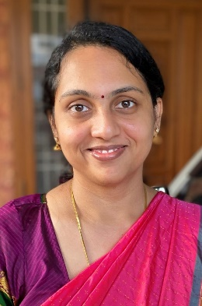The author has been awarded with Ph.D. in Vedanga Jyothisha from Yoga Samskrutham University for her research on “Stellar Effects – Nakshatra Digbala and Gunas” based on Meena 2 Naadi principles and she has also published a book under the same name based on this thesis. She was also awarded Professorship title recently. She completed her M.A in Vedanga Jyothisha from the same university. She is the founder trustee of JKR Astro Research Foundation. She has also completed her Post Graduate Diploma in Human Resource Management from Xavier Institute of Management, Bhubaneswar (XIMB) and Bachelor of Engineering in Electrical and Electronics Engineering (EEE) from Vasavi College of Engineering, Hyderabad.*

The moola mantra of Meena 2 Nakshatra Siddhantham has always been – “*A planet posited in a sign may not deliver results but its star lord will deliver the results favourable or unfavourable.”* This is the prime foundation on which Param Pujya Guruji Sri NV Raghavachary (Meena-2) has shared many gems in the form of sutras of Naadi astrology in his book ‘Practical Stellar Astrology’ which is hailed as the Bhagavad Gita of Nakshatra Siddhantham. The 40 principles that he has elucidated at the end of this book, though seem to be simple, hold powerful keys to prediction in Stellar Astrology.

In his work, Param Pujya Guruji has laid a lot of emphasis on Lagna and Lagna pada in predicting the nature of life for a native. And this is for a very good reason. Lagna is the starting point in one’s life. It represents self and therefore the entire life of the native. Param Pujya Guruji stresses on this beautifully in one of his principles in Practical Stellar Astrology, “*For the native to enjoy the fruits of a House, the Lagnathipathi or Lagna should be connected or associated with respective houses*.” (PSA Rule No 32). Without Lagna’s touch, the native cannot experience the results of any Bhava or planet to self. This very clearly outline the critical importance of the Lagna. Hence, Lagna Bala is important for a native to acquire desired status and lead a smooth life general in all aspect. Strong Lagna can propel a native to great heights and prominence. For instance, Param Pujya Guruji Meena 2 states if the Lagna Pada falls in Vargottama Uttama Drekkana, then the native is driven to an important status in the society. Such is the power accorded to the Lagna. But there is also a caveat that Guruji mentions in this rule. This power needs to be studied carefully in combination with other factors. Merely, attaining the status of Vargottama, or Lagna Lord attaining Digbala or exaltation is not sufficient. Other factors like combination of planets., constellations lords and connections etc., also need to be studied of which Guna attained by the planet or Lagna pada is a very crucial factor.

Our ancient texts and granthas have elaborated on the three gunas that are a part of the nature or Prakruti – Satwica, Rajasa and Thamasa. Traditionally, the Naadi Jyothisha attaches great importance to studying the Gunas attained by the planets while forecasting their results. However, the literature on this is limited. Param Pujya Guruji Meena 2 is the first and the only person to bring this concept of Gunas to light. After extensive research on the Naadis for more than 60 years, he has propounded an elaborate theory on the application of gunas acquired by the planet to predictive astrology. Further, he split the gunas into three steps stating that a planet can exhibit any of three gunas at a time while the other two recede to the background, depending on the circumstances created in the natal chart. Further explanation on this is provided in his Practical Stellar Astrology book.

According to Meena 2 Naadi, Jupiter and Mercury are Satwica; Sun, Moon and Venus are Rajasa; and Saturn, Mars, Rahu and Ketu are Thamasa. If a planet attains its own guna, it delivers good results. Rajasic planets should at no time get Thamasic guna, and Thamasic planet should not get a Rajasic guna. It is not harmful if a Rajasic planet gets Satwica guna, but mixed results will follow. The same results can be expected when Satwica gains Rajasic guna. However, Satwica planet will not give proper results if it becomes Thamasic. Hence, gunas play a vital role in influencing the nature of results given by the planet. According to Guruji, gunas by themselves are capable of endowing results to the native.

Guruji’ son, Dr. N V RA Raja (Jr. Meena 2) applied the above guna principles extensively to Kalamsa lords of planets in his book, “ Stellar Effects – Kalamsa Gunas”. This is the first such work and a forerunner in Stellar astrology on the application of Gunas to predictions. Kalamsa, in itself, is a concept unique to Meena 2 Naadi, and is one of the pillars of the system. Kalamsa or sub-lord theory was first introduced to the astrological society in 1946 by Meenas (1 and 2). While the Navamsa is the division of a Rasi/ sign into 9 parts, Kalamsa is the division of a Nakshatra into 9 parts, and the entire zodiac is divided into 249 kalamsas (243+ 6 bina kalamsas). This is a sookshmath Sookshma and the pinnacle concept in Meena2 Nakshatra Siddhantham where we are looking at the minutest division in the zodiac to give predictions. As per Meena (1 and 2), the position of the constellation lord as well as the Kalamsa lord of the Bhava have to be considered while studying the Bhava.

By applying the above concepts of Kalamsa Gunas to Lagna pada, we can ascertain the strength and nature of the Lagna. Let’s look at some example charts below.

**Chart No: 1 –**

This is the chart of a highly learned Sanskrit and Vedic scholar, and a great Garuda mantra upasakar. He lived till 99 years with all comforts and was in robust health till his last days performing all religious rituals meticulously.

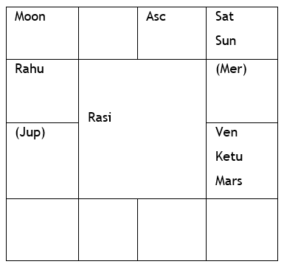

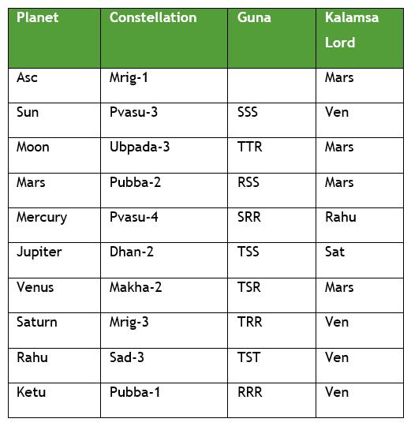

Let us carefully analyse the Lagna and Lagna pada applying the concept of Kalamsa gunas. The Lagna pada falls in Mrigasira-1 in the Kalamsa of Mars itself.

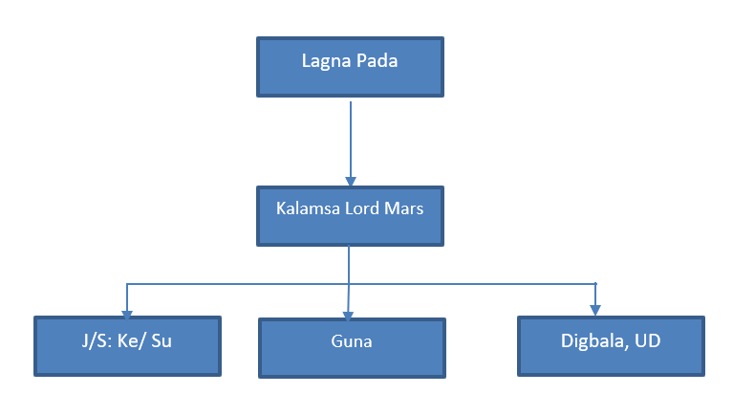

The Lagna Pada falls in the Kalamsa of Mars which has attained a largely Satwica guna (RSS). It is also powerful with Nakshatra Digbala being aspected by Rahu from the 10th house, and in Uttama Drekkana. Mars which is the karaka for vitality and strength, being powerful and in largely Satwica guna, bestowed good health and longevity to the native.

Kalamsa Lord Mars is in the star of Venus which is in conjunction with a more powerful Ketu which has attained Digbala. Hence, Ketu snatches Jeeva power from Venus. Ketu is also in Venus nakshatra, hence the house lord Sun becomes Sareera. The Jeeva planet Ketu is in the 4th house in Sookshma Nakshatra Parivarthana with Lagna Lord Venus. (Please note the transfer of Gunas between Ketu and Venus. Ketu gets mixed guna and Venus gets RRR guna from the latter through this exchange). Now Ketu represents and fortifies the Lagna, gaining connection through the Kalamsa lord. The Sareera planet Sun is in pure Satwica guna (SSS) with Digbala and in Vargottama Uttama Drekkana (VUD) touching the Yogakaraka Mercury through Binapada.

Ketu is the gnana karaka and Sun is the karaka for providing mastery. Being Jeeva and Sareera for the Lagna Pada kalamsa lord, both are well placed with pure Satwica influence and dominance coming in the picture. Satwica guna is the embodiment of spirituality and enlightenment. 4th Lord Sun, being the Sareera planet for Lagna pada Kalamsa lord, is sitting in the 2nd house (Vak sthana) with pure Satwica Digbala along with 9th Lord Saturn, touching Yogakaraka Mercury (karaka for Vedic learning). All these karakatwas got enhanced in this case and gained connection with Lagna through the Kalamsa. This prompted the native to learn Vedas, master Sanskrit and become spiritual scholar. The Lagna bala and dominance of Satwica, Rajasa gunas through Lagna pada Kalamsa lord made the native a spiritually enlightened person and lead comfortable life in all spheres.

**Chart No: 2**

The native was a prominent IAS officer and rose to the position of Additional Secretary of State. He had a large following of masses and was also a highly spiritual person.

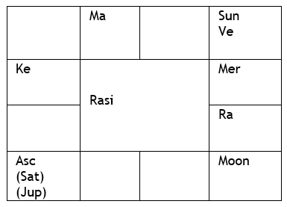

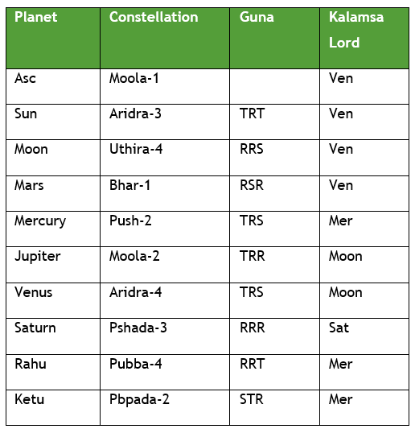

Let us analyse the Lagna pada in this case. Lagna pada falls in Moola-1 in the Kalamsa of Venus.

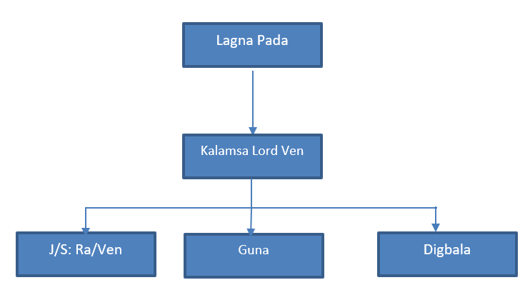

Lagna pada falls in the Kalamsa of Venus which has attained mixed guna (TRS) – a desirable one as it is largely Rajasa Satwica guna. Venus is powerful with Digbala being aspected by 4th Lord Jupiter and it is also in rapt conjunction with Yogakaraka Sun (Karaka for Govt service and authority).

Venus is in star of Rahu which becomes Jeeva and Rahu is in the star of Venus. Venus with Digbala becomes powerful in the combination with Sun and becomes the Sareera planet. Jeeva planet Rahu is in Yogakaraka and 9th house. Both Rahu and Venus are being aspected by a powerful Lagna Lord Jupiter from the Lagna itself and Jupiter is also in a largely Rajasic guna (RRT). It is important to note that Rahu and Venus are in Sookshma Nakshatra Parivarthana with each other. (Please note the exchange of gunas as well. Rahu gains mixed guna in the process and Venus get its own Rajasa guna). Hence, both Jeeva and Sareera of the Lagna pada Kalamsa lord Venus, are well fortified with Yogakaraka, strong Lagna and 4th connections. Also, note the strong dominance of Rajasic guna in all the connections. Rajasic guna is important in providing positions of power and authority. This connection gets doubly reinforced through the Kalamsa lord of Lagna Pada. Hence, the native could rise to a very high position in the Govt. Lagna bala through Lagna pada and strong Rajasic combination from Kalamsa lord is a strong reinforcing factor in this case as well.

Hence, we can see from the above cases that when the Lagna pada lord falls in the Kalamsa of a planet which attains desirable guna and is well placed in the constellations, the native attains prominence.

**Jai Meena 2!**

Om Sri Veeraraghavaya namaha

# An Astrological Analysis of CAREER BREAKS

-Prof.Sarada Devi Ph.D.

*Dr. Sarada Devi, is a professional astrologer. She is a disciple of Dr. NVRA Raja and learning Meena 2 naadi system under his guidance with the blessings of Parama pujya guruji Sri NV Raghava Chary Garu. She has been awarded with PhD for her research work on “A study on Binnapada Concept-Based on Meena2naadi principles” from yoga Samskrutham university Florida, USA.*

Generally, when we look at a birth kundali for career prospects, we normally check the time period for promotion, transfer etc. But this pandemic made us look at another angle of career astrology i.e., breaks in career.

In spite of having good experience and high qualifications, many people lost their jobs during this pandemic.

In this article, I try to explain astrological reasons for breaks in career.

First, we see primary houses for career:

- 2nd house, house of income

- 6th house (mental stress, service, atmosphere at workplace)

- 10th house, house of profession

- 11th house, house of labha

- Karaka planet Sun

- Natural 10th house Capricorn.

**Reasons for Career breaks**:

- Weakly posited Lagna lord. For anyone to reach good heights, their Lagna should be strong.

- Weakly posited 10th lord or associated with 6th ,8th ,12th houses and their lords.

- Association of Saturn with 2nd house and karaka planet.

- Rahu and Ketu.

Now I am going to explain the above rules with the below example chart.

This native has 20+ years’ experience in his field. In spite of having good experience, he had two major breaks in his career and he had differences of opinions at work place with colleagues and management.

Here, I will explain his chart, by using Jeeva and saree concept and Binnapada concept. Jeeva and sareera and Binnapada theory are main and sub pillar of Meena2naadi system respectively.

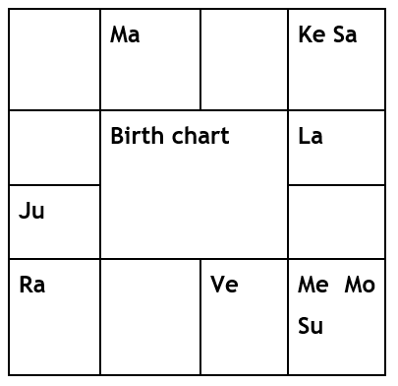

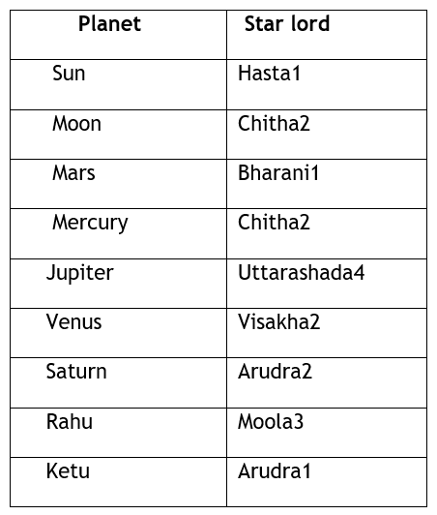

**Analysis**:

In this chart, the 10th lord Mars is in its own house. But in our naadi system we give more importance to star lords. Here Jeeva planet for Mars is Venus and Sareera planet for Mars is Jupiter.

By looking at Mars and Jeeva planet Venus, both are posited in their own house. Being a 4th lord, Venus should give a comfortable state at the workplace. But he felt uncomfortable and had some differences of opinions at the workplace. Here, Venus is associated with Mercury, the 12th lord. By posited in Binnapada constellations Mercury gets associated with Venus. And by posited in Binnapada constellation Visakha, Venus is also associated with its successive house Scorpio through forward Binnapada. Now Venus has connections of 12th house and Natural 8th house.

Coming to Sareera planet Jupiter, it is posited in its debilitation. But by positing in Binnapada its debilitation is nullified. But here Jupiter is associated with 6th house (workplace atmosphere), Rahu (here Rahu acts as 6th lord) and receiving the aspect of Saturn (strong 8th lord), Ketu.

When we look at Mars and Venus, we think that they are positioned strongly, so native will enjoy good results regarding their profession. But when we go to micro level by using Meena2naadi system we can find that Jeeva and sareera planets of 10th lord Mars have the connections of 6th ,8th ,12th, badhaka houses, and Rahu, Ketu. This connection may impact his professional life.

Now we will see some observations regarding time of career break:

- If DBA lords have connection with Jeeva and Sareera planets of 10th ,9th,3rd,5th (6th,8th, and 12th houses from 10th house) and badhaka, at that time chances for job loss are more.

- At that time, we can also observe the connection of ketu with the above DBA combination.

- During the above said Antara, when Sun has an aspect of Saturn in transit, at that time native will face more work stress/loss.

**Timing of Event:**

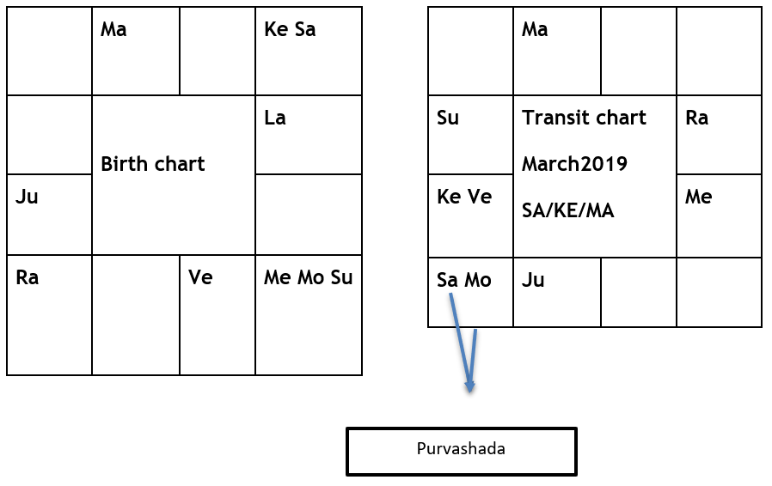

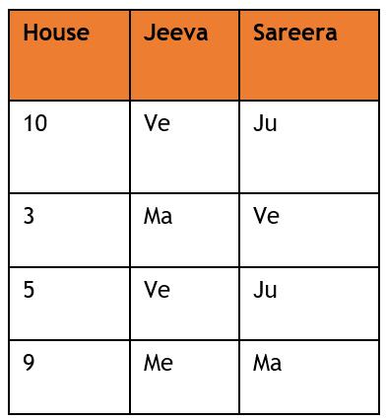

**Timing of Event analysis:**

- Dasa planet Saturn is transiting over natal Rahu and Jupiter (by binnapada Jupiter is associated with Sagittarius). Jupiter is a sareera planet for 10th and 5th houses. Saturn is transiting in Venus star Purvashada, Venus is either Jeeva or sareera planet for 10th, 3rd and 5th houses.

- Bhukthi lord Ketu is transiting along with Venus. Venus is either Jeeva or sareera planet for 10th, 3rd and 5th houses. Ketu is transiting over natal Jupiter. Jupiter is a sareera planet for 10th and 5th houses.

- Antara lord Mars is transiting over natal 10th house and aspecting natal Venus. Venus is either Jeeva or sareera planet for 10th ,3rd and 5th houses.

**Simple Remedies for Career Breaks:**

- Donate food on NEW MOON Day

- Chant Suryaastakam Daily

- Chant Kanakadhara sthothram daily for 21 days

**Reference**:

Stellar Effects-Jeeva and Sareera by Dr. NVRA Raja Ph.D.

Binnapada, class lectures by Sri Raja Sir.

# AArthika Panchaka

Prof. Raghunathan

As Astrologers, sometimes we feel thrilled to get hold of horoscope of a Tata, Birla or Ambani and try to decode the chart to find out how these people could raise such lot of money in a lifetime. Apart from their own prosperity, the charts also reveal how this huge wealth was used by them for constructive uses like starting industries, giving employment to lacs of people and help in putting nation’s economy in good shape.

Similarly, when we check horoscopes of people like Dawood Ibrahim, Al Capone , we see how same amount of wealth can be generated by dishonest, criminal and unethical means.

Generally, you will find 2and 11 houses coupled to houses 10 and planets like Jupiter or mercury, show up in charts of good people while Saturn , afflicted mars and rahu show up powerfully in horoscopes of gangsters and rich smugglers who also make up a big pile of wealth.

When viewed philosophically about the way above people have passionately gone about amassing wealth, we find that success or failures of their efforts , depend on certain basic factors. In this article we will try to learn about these factors. Understanding these factors will help us to read the horoscopes better by studying the inter play of these factors.

We talked about four types of arthas coming under the heading Purusharthas. Every human being born on this earth will strive to achieve these Purusharthas in some form or other. He is duty bound to do so not only for his own security and prosperity but also for sake of all those who are dependent on him. Whatever be the artha the self is seeking to achieve, he will have to understand five basic natures of the artha before venturing to put in his efforts. These basic natures of arthas come under the name **Arthika panchakas**. These are

1.nature of the objective to be attained

2.nature of one ‘s own self

3.means of attaining the said artha

4.Fruits of attainment

5.Obstacles that come in the way of attaining the said artha.

To illustrate above five natures of arthas, let us consider artha, the second of 4 Purusharthas. Artha generally means Money, Finances, resources, capital etc which can be used to buy, procure, get to own a particular item to satisfy some want. For simplicity let us take money to explain this point. We need to understand what is money, where is it, its form , its value, purchasing power, ways of carrying it, saving it and protecting it etc. The money can be obtained by some way, but if we don’t know its nature, we may be wasting our efforts in getting it. It may be too unwieldy, it may be dangerous to keep, difficult to transfer or exchange. Suppose we get paid in terms of diamond pieces, there may be difficulty in exchanging it for procuring goods that we want ,if we cannot attach proper value to it. Secondly, we may not be able to protect it because knowing the value of diamonds others may want to take it away from us. So, we will put ourselves into different types of problem.

Secondly, we must know about what we are, our worth, capability, skills and short comings. based on our strengths and weaknesses only we must aspire for artha. If this awareness is lacking, we will put in disproportionate efforts and fail to acquire what we seek. This will lead to frustrations, heartburns, jealousy, greed with consequent and attendant difficulties and wrong actions.

Thirdly we must get to know all about the ways of getting that artha. Whether it can be obtained in exchange of goods, service or some other means Some of the services required may be very much outside our capability or resources available with us. Some work can be finished fast and some may take long time .It may also happen that some tasks may call for more than person. In that case we must be able to mobilise additional manpower and tools .Some of the means of acquiring the artha may be ethical and there may be un ethical means operating also.

Fourthly we must study the fruits associated with acquired artha. They may last a very short time or long time. Satisfaction may be less or more. If the results are negative, can we make more attempts by changing the means. Does it affect one person or more?

Lastly there may be many hurdles that may come our way. In the processes of overcoming the hurdles we may waste ourselves. Knowing these hurdles beforehand will help us to plan our approach, strategies, tooling and support staff.

Hence acquiring any ARTHA involves several sets of actions good and bad, with respective karma impact during present life or later life.

**Additional features of ARTHA**

Artha also includes following wealth. Acquiring these wealth places an individual in a position of advantage in tackling PROBLEMS ARISING OUT OF KARMA

1. knowledge as wealth

2. Health as wealth

3. contentment is also a wealth

**TATWA THRAYA CHINTANAM**

The soul that becomes subject to karma is always under many illusions Due to these illusions he acts as though the karma will affect every body but him.so he is devastated when the effect sets in. He believes it is very unfair and does not deserve the sufferings. Our sages have identified three main illusions calling our attention.

These three are called tatwa thraya chintanam

They are

1. Body itself is the soul

2. Soul is completely independent

3. There is no supreme being

To really understand these illusions, one has to know concept of jeevatma , paramatma and how soul sees itself. It can become quite complicated. This will lead to concepts of dwaita, adwaita etc. We will not venture into those areas. We will take a simpler path by assuming that there is a soul which takes different bodies at different times .This body and soul together become the life form that can act on its own devices. Actions are required to acquire different types of arthas mentioned above.

The first illusion that dominates our mindset is that the body we have is itself the soul. This compels getting involved in action. This is where the ego comes in claiming credit for action Along with credit comes suffering too. At times of action, this is totally forgotten.

Second illusion is that soul is totally independent. It can take all decisions regardless of all consequences. There is no fear of consequences. immediate result is more important. We plunge into action and face the consequences. We are aghast when things go awry and look at others to be blamed.

Third illusion is about existence of God or some super supreme being who has ability to regulate our action. we refuse to believe that all our actions are dictated by His will and pleasure. He has made certain sankalpam about us and we cannot beat him thinking we can achieve everything on our own strength.

These three illusions make our karma worse.

**Concept of Upayam and Upeyam**

For every artha we choose to attain, there is a Upayam and upeyam. The object we wish to attain is the upeyam and the means we adopt to achieve that objective is called Upayam. on account of illusions that we carry in our own mind as mentioned above, we act on our own resolve, using our own resources, effort and time. Depending on our karma we succeed and are able to enjoy the fruits of our labour and achievement of objective. We believe we have achieved on our own. At times we fail. all our efforts are wasted and huge loss is looming in front of us. We have nobody to blame and we are consumed by our own sense of failure. This is also impact of karma.

The reason of failure is that our Upayam of depending on our own resources to acquire our artha was found to be inadequate. What is lacking?

We forget to associate that supreme being with our work. We did not seek His support, His blessings.

We forget we are not independent. Forces of God and karma work at cross purpose. We need God to manage our karma. So along with our own resources, efforts, devotion, sense of commitment and urgency, we need to include god’s blessings also as Upayam. He becomes our Upayam to help us achieve what we want. This is where faith ,prayers and devotion take their place in our life.

**Concept of Prapatti**

The moment we acknowledge need of god’s blessings as part of our Upayam to achieve a particular artha, we are well on the path of Prapatti. Prapatti is a sure-fire way of managing a task. what we need to do is to strengthen our faith in God, without letting down any of our commitments in terms of resources employed, efforts put in and sincerity of purpose towards the task on hand. As we strengthen our faith in him, acknowledge our need of His continuous support and inadequacy of our resources and capability, our success rate will improve. what we have to do ultimately is to carry on with our task as His task, our labour as His labour and our wishes as His command, we become his responsibility and he will deliver for us. For that we have to become worthy of His association. To become worthy, we have to adapt, cultivate new mindset and persevere with our efforts without let up. total faith in him is Prapatti. That is ultimate surrender. Prapatti is lot more but if this limited understanding comes into us, we are making ourselves better off.

We cannot manage our karma without His support. The earlier we realise this, it is better.

The person who has taken refuge in God, and entrusted responsibility for his protection and all his actions are as per the lords dictates, in line with norms stated by Him in the scriptures and has offered all fruits of his action to the Lord , is said to have attained Prapatti and such a person is called PRAPANNA OR Dasa.

**Pursuit of Dharma**

Dharma is the first of 4 Purusharthas that we must manage in our pursuit of all Purusharthas. It decides that methods we adopt ethical or not, the limits we draw for ourselves in our action.do we kill to achieve some thing or adapt some other way like cheating, thuggery, seducing etc. This will lead to success or failures and other good or bad consequences as per karma. Even thieves have a dharma of their own. Whatever be the dharma there are certain principles to be understood. This will help in managing the dharma.

**Ten Principles of Dharma**

The person who is in pursuit of Dharma should bear in mind following 10 principles to govern his life.

These are

1. Forbearance, the ability to remain calm in all circumstances

2. Control of mind to avoid temptation, harsh speech and violent responses

3. Kshama-ability to forgive

4. Not stealing and not coveting others property

5. Cleanliness of body , mind and actions

6. Wisdom to understand right ways and when to use

7. Be truthful all the time

8. Adopt ahimsa and nonviolent ways.

9. Respect elders, well read and social reformers.

10. Control of senses

**Principles to be followed while pursuing kaama**

Kama is the third of 4 Purusharthas. It does not necessarily mean anything to do with pursuit of sensuous pleasures. It includes all desires material and non-material pleasures. The passion associated with pursuit of these objectives will decide whether result will be good or bad. We have seen in stories of Romeo Juliet or heera-panna , how pursuit of love does not always have happy ending. same applies to achievement of all desires. hence, we must understand certain factors. These are

1. Wisdom

2. Discrimination

3. Moderation

Wisdom is ability to decide whether a particular objective chosen by us is feasible or not. Whether it is worth our efforts, whether it suits our image, culture and our status etc.

Discrimination is the mental exercise to distinguish between good and bad, risks assessment and results being short lived or long term.

Third relates to enjoyment. Over enjoyment and more frequent experiences can lead to side effects which we may not be able to handle. we know all about problems faced by drug addicts.so moderation of some sort becomes necessary

Thus, three factors mentioned above have very important religious connotations.

So, when we study horoscopes, it will help to apply above principles properly to decide strength of individual to deal with Purusharthas.

# 4th HOUSE

*-Muralidhar Patnaik K.V.*

*Faculty member & Research Guide*

*JKR Astro Research Foundation*

The ‘root causes’ of life can be obtained by measuring and understanding the ‘influence of celestial objects’ with the help of “Tools” provided under Jyothisha Shastra. The basic TOOLS are – ***Rashi Chakra*** (Zodiac Wheel), ***Bhava Chakra***(Wheel of the Houses) with the ***Graha Sthithi***thereininterpreted mainly through ***Rashi Karakatvas, Bhava Karakatvas*** *and* ***Graha Karakatvas***(i.e., Signification of Zodiac Signs, Houses and Planets) The basic tools gifted by our Rishis to measure & understand the celestial influence are:

1. The Zodiac Wheel– Rasi Chakra– Kundali through Nakshatra & Rasi Karakatvas

2. The Bhava Chakra (Wheel of the Houses) through Bhava Karakatvas.

3. The Positions and Association of Planets in Zodiac and Bhava Chakra through Graha Karakatvas

In Astrology, the Zodiac Wheel (12 Signs) – the “Rasi Chakra” and the Wheel of 12 Houses – the “Bhava Chakra” are two separate entities. In the Zodiac Wheel, counting of Signs starts from the Aries (Mesha) Sign. In the Wheel of Houses (Bhava Chakra), counting of Houses starts from the Ascendant (Lagna)

The houses are the **fields of experience**, not the **experience themselves**. The **kendras** (or Quadrants or Angular houses) are **Houses 1, 4, 7 and 10**. These are highly significant houses.

**Now let us confine to 4th house.**

4TH HOUSE means 4th sign or 4th cusp from the Lagna or 4th bhava from the Lagna. 4th house means natural 4th house also. We have to take natural 4th house also to reckon for predictions along with the significators of 4th bhava or 4th cusp.

Fourth house is all about your roots. Just like roots of tree as vital for its existence, 4th house is important to know your basement, your origin, your childhood. It signifies one’s Home, house, residence, domestic environment, Mother, Comforts in life, School education, one’s landed property or immovable property, vehicles, real estate matters etc. Everything that refers to strong ties to your native place comes under 4th house. Relationship with mother & homeland, heritage, family values, and associations are also governed by the planetary position in the 4th house in horoscope. Overall, this is the house of domestic happiness 4th bhava is called generally Matru bhava. It is also called Sukha sthana (house of comforts).

Every bhava will have one karaka planet and that karaka planet plays significant role in deciding the fate of the event. For 4th bhava, Moon and Venus are karakas. Venus is for comforts. As education is allotted to this bhava, Mercury is also reckoned as karaka by some scholars.

This bhava denotes the native’s education and qualification of a person. It indicates in present conditions education up to Intermediate level. Graduation, Post-graduation and further studies are indicated by 9th house.

In natural 4th house, Karkataka We have 3 stars. Punarvasu, Pushyami and Ashlesha. Education is allotted to this house. Lord of Punarvasu, Jupiter is the Guru who holds the student and starts teaching and during Pushyami, Saturn stage, makes the student to work hard and learn the subject by doing service (Saturn indicates service) to Guru and during Ashlesha, lord being Mercury, basic education culminates into perfection. Hence Mercury is karaka for education.

Generally, guru lives in a river side ashram and disciples join there to learn. Karkataka indicates river side. As it is education house, Guru plays dominant role. Hence Guru is exalted here. Whereas the Lagna, the self, the native Mars who is shishya here cannot dominate Guru and simply has to follow Guru by invoking Saturn rendering service to Guru to get complete education by invoking Mercury-Ashlesha. Hence Mars is subdued here. The attitude and self-ego and dominance of Mars is toned down by the Jupiter here. Hence Mars is debilitated here in Karkataka. If Mars is strong in 4th house, he may not learn to perfection.

If 4th house and Mars are favorable, during their conjoint period, one will buy lands or buildings. If they are unfavorable, the native may sell away lands or there can be loss through the investment on lands, buildings etc.

Similarly, 4th house indicates House, Vehicle. if 4th house and Venus are favorable, the native will purchase car or any such vehicle and enjoys travelling by luxurious vehicle. If not favorable, he will incur expenses by meeting with accident or repairs or sell away the vehicle. As guruji Dr. Raja Sir told, if 4th house and Venus are favorable, he will enjoy luxurious vehicle even though he is not an owner of the same. Somebody will give lift. Similarly, he can travel in an upper class I or II or at least III AC in a train. If not favorable, the native even though owns a higher end car, will be forced to travel by public transport or an ola car or uber taxi. The WL in AC class status will not be confirmed and he has to travel in a general class or at best in sleeper class.

4th house indicates Mother. If 4th house and Moon are favorable, the native will have long living and helpful mother. If unfavorable, mother may pass away in early stage or she may not be helpful in any manner and the native has to serve a sick mother as the 4th house indicates health of the mother.

The loss of children (comforts through children) is also indicated by 4th house as it is 12th to 5th house, which indicates children.

4th house indicates Mind. If 4th bhava is afflicted, the native will not be peaceful and takes unwise decisions landing into problems. If Lord of 4th bhava and Moon are well placed, planets in Punarvasu 4th pada, Pushyami and Ashlesha will give favorable results.

Karkataka Lagna the 4th lagna is controlled by mind and hence the natives born in this Lagna can be influenced by counseling or by conversation either positive or negative.

Home and family life are the makings of 4th house. The effects of planets and signs in 4th house are most powerful during childhood. Things like career (10th house), work (6th house) or marriage (7th house) are very big for a child point of view. Children live in the first through 4th house as it represents home. Planets and signs describe the atmosphere of your home, whether it is easy going or full of struggle because parent’s attitude and behavior shape the home life of child. It marks your journey of whether you build a house (of bricks and mortar) or a home (of family values and ties). When you are able to get the best of both worlds, you are at peace with yourself. The 4th house planets and signs go on to shape the home and family life of a native, his attitude and interests and feelings towards home and family.

4th house thus symbolizes and shapes the childhood of a native. In child hood, only mother, father and Teacher play significant role. Mother (represented by Moon), since from the sunrise time to school going time, will be caring the child looking after the needs of the child. In school, major part of day is controlled by Teacher (Guru-Jupiter) teaching him the basics of education. After coming from school, Mother takes over charge and takes care of the native’s food and homework and bed comfort (proper sleep). Here, father (Sun) will only supplement what is required and will not have a chance to play significant role because he is more concerned to supply the necessary inputs which will make the child comfortable at home and at school. So, 4th house is mainly dominated by Mother (Moon) and Guru (Jupiter). Hence Moon is karaka and Jupiter is exalted. The comfortable position of child is signified by Venus.

Fourth house thus also refers to mental peace and emotional satisfaction. The idea is to create a sanctuary, where everyone can live under one roof with compassion and love. Societal norms, material security, family history, ancestry, culture, lifestyle and traditions also fall in the realm of this house.

It refers to the domestic environment, the condition of your family in the later part of life and how you handle familial issues. It also tells whether the person lives close to or moves away from the native place.

Fourth house essentially marks our journey from the womb to tomb. Womb refers to the mother, our dwelling place, from where we originated, and to what we are most attached. It refers to the roots from where we grow, the place we call home. On the other hand, it also refers to old age, our final resting place. The ground or Earth from where we grow up is where we have to return one day.

Now let us see the effect of planets in 4th house.

The native with 4th house Sun will not be happy unless their home is happy. The native strives to make the home environment active and alive, loving at the same time. The native takes pride in their heritage, respect ancestors, family making childhood positive and purposeful.

For a native with Moon in 4th house, home and family are paramount as they treat home as their sanctuary. Emotional level is high and any disagreements will be taken to heart. Whether for better or worse, they have deep relationship with their parents especially with mother. They spend good time with mother giving emotional support to her. When they create their home separating from their mothers, they do carefully always keep their mother’s feelings in mind. They welcome the continued support of their mother as she is a priority in their life.

Mercury in 4th house brings a well nit family, unbiased, slightly detached to deep emotional house. Communication among family members is assisted by Mercury. If there is a tension because of disagreements, Mercury intellectually breaks the things into rational pieces to find out a solution without the emotional drama. Using words rather than feelings to solve problems and keep the home in peace is the role of Mercury

Venus, always polite and amicable with family members wants a pleasant home life when posited in 4th. A well decorated, clean house is ensured and family life and family heritage are valued greatly. Venus always sees good side of home life overlooking the negative as a child as well as an adult.

A 4th house Jupiter wants a large bustling home with children, friends and relatives sharing joyful atmosphere. Desire for large property, likely inheritance of property, propensity for owning animals can be attributed to Jupiter. The childhood is unrestricted and there is a plenty of opportunity provided by the family in terms of financial and emotional support. When grown up, the native allows his children ample space to explore and experience the world. An open and honest attitude with family members is found when Jupiter is in 4th house

When Saturn is in 4th house, Family and home life can feel restrictive and burdensome. Childhood may suffer financially or emotionally. The childhood experience was not easy. This feeling is transferred into adulthood causing the fourth-house Saturn person to see home and family as a restrictive responsibility. At best, the chart holder simply takes family life seriously and is a responsible provider and caretaker. At worst, family is seen as unbearably restrictive and the native longs to escape from it, or avoids establishing a traditional family fearing that it will be a burden. There may be scars in the family heritage that the chart holder does not want to accept.

Last but not least, Mars, satisfying the needs of the will in the fourth house, can be difficult because Mars is an impatient, conscious planet and doesn't have time for, or understand the emotional undercurrents which are better dealt with using patience and tact. To complicate it further, the house inextricably involves family members with whom the relationships are extremely close and even vital. Because Mars only serves the will of the native, delicate family emotions are often dished a harsh blow by Mars' aggressive, determined and intrinsically selfish style., the vital relationships with parents and children can be harmed, leaving Mars feeling uncared for and alone. That is why Mars is not strong and respected here.

Rahu and Ketu are sensitive planets and deliver the results of the planet with whom they are associated as per pancha siddhantha.

Fourth house in Mundane astrology refers to mother land, agriculture, weather, climate, mines, and public buildings. Parliament. Fourth house is also related to all that is under earth such as oil, mining, excavation, agriculture, extraction of natural resources and construction

**Thus 4th House is termed as Matru, Vidhya, Bhumi, Vahana, or Sukha Bhava, Shaurya or Sahaja Bhava.**

**Fourth house denotes** Near and dear ones, caste and ancestry, mother, relatives on mothers’ side, lands and houses, farming, gardens, orchards, installations, buildings, medicine, education, knowledge of land and geography, hidden treasures, comforts and discomforts, courage, faith, victory and defeat, perfumes, clothes, milk, digging, agricultural produce, vehicles, possession of cattle. Fundamental rights of citizens and comforts provided to the people are the key areas of 4th house in Mundane astrology.

**In Medical Astrology :** Chest, lungs, heart, breast, potent, blood, circulatory system, medicine. Punarvasu 4th pada indicates beri beri, stomach upset, TB, bronchitis, liver complaint, jaundice, poisoning of blood etc. Pushyami indicates Gastric ulcers, gall bladder stones, injuries or cuts in the breast, cancer in chest region, cough, jaundice, eczema, pyorrhea. Ashlesha indicates Vitamin B deficiency, cold, breathing problem, drunkenness, hysteria, nervous disorder, indigestion etc.

**Source of inspiration:**

Guruji Prof. Raja Sir during his speeches in Classroom and as well as in Faculty meetings shared valuable points and some of them are mentioned in this article.

*Pranams to Pujya Guruji Sri N.V.Raghavachary garu and Pranams to Guruji Prof.N.V.R.A.Raja Sir.*